Sponsor an Inmate

You can help an inmate come heart to heart with the love of God by financially sponsoring him/her for the Kairos 3 day weekend. It costs $ 150 per inmate, or
$900 per table family. Families, reunion groups, and Sunday school classes can help sponsor an inmate into a new life – one based on Christ.

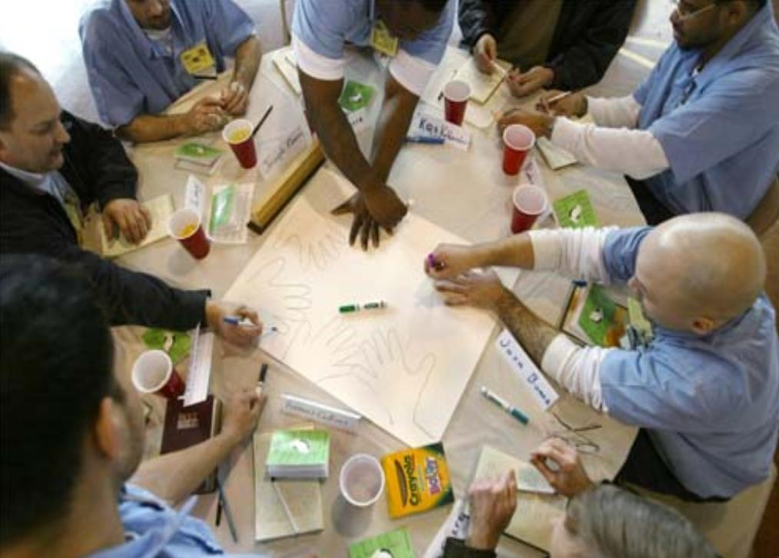

Mail your contributions to:
Kairos Prison Ministry
Your Treasurer Address Here

Purchase a Meal

You can contribute to the purchase of an inmate’s meal by filling out the meal ticket below and sending it and a recommended donation to the address above.

Your Unit/Weekend # here 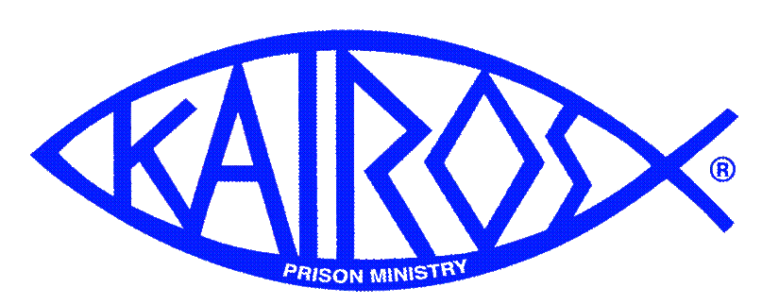 This meal has been provided by:

Name: ______________________________

City: ________________________________

Attend a Closing

Come to the Closing Ceremony on insert your date here and be a witness to the glorious work of the Holy Spirit. You must submit an application and be approved to attend the Closing. Visit your website address here for an Application, a map, and dress guidelines for the Closing.

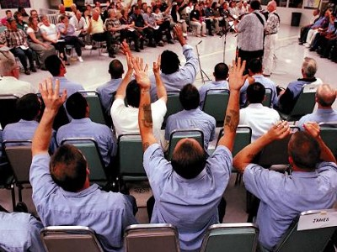

Lives are being redeemed in one of the darkest places on earth – prisons. It takes a virtual army of volunteers to be the hands and feet of Christ in this mission. Some actually go into the prison for the 3 Day event and some cook meals while many, many others contribute donations, posters, placemats, cookies, and write letters. All can be in prayer.

Your contributions are part of God’s plan to bring the light of Christ into this very dark place. Thank you for being willing to be in His plan.

Kairos Prison Ministry

Volunteer’s
Guide

Your Unit Here
Your Weekend Dates Here

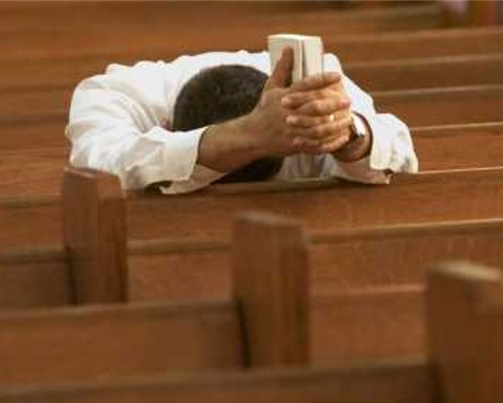

When you did it to the least of these, you did it to me.
Matthew 25:40

A Great Cloud of Witnesses

Kairos unites Christians to make a difference for Christ in the hearts of prisoners.

Kairos is an ecumenical, worldwide ministry that brings the love of God and the light of Christ into prisons. An army of volunteers rally to become the hands and feet of Christ for 42 inmates who come seeking a new way of life.

How Can You Help?

Prayer…
Our Greatest Need

We need your prayers for the success of the mission. Please pray for:

-Residents for the Weekend
- Warden
- Chaplain
-Kairos Weekend Leader
-Support Team
-Our host Church
-That the will of
God be accomplished

Make Cookies

Home made cookies, filled with prayer and love become tangible examples of he love of God poured out by His family.
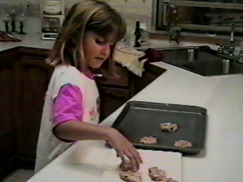
Cookies must be made in a kitchen with a Health Dept certificate.

What Kind of Cookies?
Chocolate Chip, oatmeal raisin, peanut butter are favorites

Cookie “Please Do’s”
-Cool, Cool, Cool!!! Otherwise they stick
-One dozen in a quart size zip lock bag
-Freeze until you can arrange for delivery
to a team member

Cookie “Please Don’t Do’s”
Don’t add icing or toppings to the cookies

Make Placemats

Make Placemats

At each meal, placemats made by children are used. These hand made placemats are powerful tools of the Holy Spirit that can break open a lifetime of sorrow and let the love of Christ in.

This is a great activity for Sunday school, preschool, children and grand children!

Placemat Guidelines
-Decorated by children
-Simple message of God’s love
-Include child’s first name only and age
-Preferred size is 11 x 17

Make Posters

Sunday school classes, Bible study groups, reunion groups, youth groups, and even families can make a poster that expresses the hope found in Christ.

These messages of
love from the Body of
Christ have a powerful
impact on hardened
hearts.

Poster Guidelines
- What is on the poster is not so
important. It can be a simple trace of
hands or a beautiful work of art.
- It should have the name of the group
- It should have the group’s signatures
(if kids, first name only and age)
- No stickers or glue.

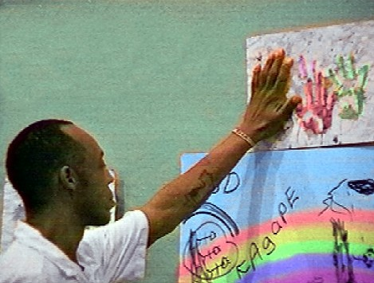

Write Letters of Hope

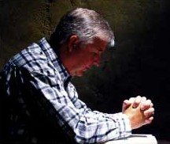

Write letters from God’s family to the inmate expressing God’s love.
- Address to “Dear Brother in Christ”
- Don’t seal the envelope
- Short “note” from children has an
Incredible impact for Christ!
- Children (first name only and age)

